**Custom JRE Testing Screen Shots**

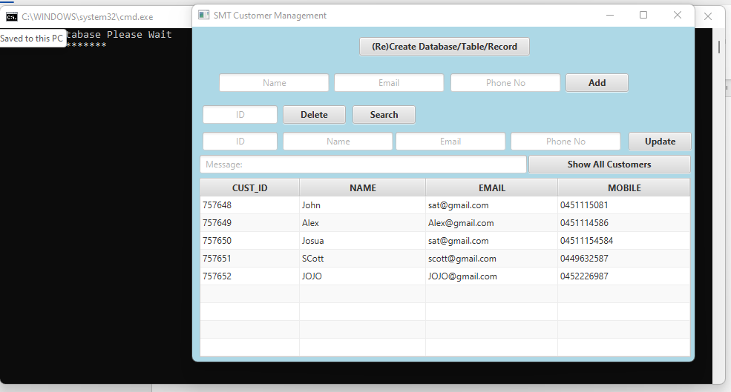

Figure Application Launched using Custom JRE

Figure Adding Data to Database

Figure Data Added and Fields has been clear

Figure Deleting by ID

Figure Above written ID has been deleted

Figure Searched by ID and displayed in the appropriate fields

Figure Record has been Updated

Figure Selected row from the table can be displayed in the appropriate fields